
RESPONSE SCHEDULES
2025 DRFA RESTORATION WORKS – PACKAGE 2
CONTRACT NO: ESC2026-006

Response Overview and Checklist
The Respondent is to attach this checklist and all of the documents and information stated in the table below, to its Response. Except where a Response Schedule provides otherwise, a Response which does not include this checklist and all of the information below may be treated as a Non-Conforming Response.
Item | Included – Yes | Included – No
Tender Form | ☐ | ☐
Schedule A – Respondent’s Details, Conflict of Interest and Legal Matters | ☐ | ☐
Schedule A1 – Respondent’s Details | ☐ | ☐
Schedule A2 – Respondent’s Further Details | ☐ | ☐
Schedule A3 – Conflict of Interest | ☐ | ☐
Schedule A4 – Legal Matters | ☐ | ☐
Schedule B – Solvency and Financial Details | ☐ | ☐
Schedule B1 – Solvency of Respondent | ☐ | ☐
Schedule B2 – Financial Details of Respondent | ☐ | ☐
Schedule C – Insurances | ☐ | ☐
Schedule C1 - Insurances | ☐ | ☐
Schedule D – Business Profile (Local Content, Employment and Environmental) | ☐ | ☐
Schedule D1 – Local Content | ☐ | ☐
Schedule E – Experience and Capability of Respondent | ☐ | ☐
Schedule E1 – Similar Engagements Currently Underway | ☐ | ☐
Schedule E3 – Works to be completed concurrently | ☐ | ☐
Schedule E4 – Resources | ☐ | ☐
Schedule F – Experience and Capability of Respondent’s Key Personnel, Subcontractors, Suppliers and Consultants | ☐ | ☐
Schedule F1 – Key Personnel | ☐ | ☐
Schedule F2 – Subcontractors, Suppliers and Consultants | ☐ | ☐
Schedule G – Management Systems | ☐ | ☐
Schedule G1 – Work Health and Safety | ☐ | ☐
Schedule G2 – Environmental Management | ☐ | ☐
Schedule G3 – Quality Management | ☐ | ☐
Schedule H – Methodology | ☐ | ☐
Schedule I – Program | ☐ | ☐
Schedule J – Pricing, Cash Flow and Variation Rates | ☐ | ☐
Schedule J1 – Pricing | ☐ | ☐
Schedule J2 – Cash Flow Projection | ☐ | ☐
Schedule J3 – Variation Rates | ☐ | ☐
Schedule K – Statement of Departures | ☐ | ☐
Schedule L – Additional Information | ☐ | ☐
Schedule M – Australian Government Work Health and Safety Accreditation Scheme | ☐ | ☐

Tender Form
Contract: 2025 DRFA Restoration Works – Package 2 – Contract No. ESC2026-006
[TENDERER TO INSERT CORRECT LEGAL ENTITY OF RESPONDENT] (Respondent):
offers to carry out and complete the work described in the Request for Tender in accordance with the Request for Tender incorporating: |  | the Request for Tender Parts 1 to 6; and  Addenda numbered [INSERT] to [INSERT]
for the sum of:
Price in figures (excluding GST): |  | $[RESPONDENT TO COMPLETE]
GST in figures: |  | $[RESPONDENT TO COMPLETE]
Price in figures (including GST): |  | $[RESPONDENT TO COMPLETE]
('the Price');
agrees that it will complete the Works within |  | [RESPONDENT TO INSERT NUMBER OF CALENDAR DAYS OR WEEKS] of the date of acceptance of the Response;
acknowledges that it has read and understood the Request for Tender and in particular all of its obligations under, warranties given or to be given in, and representations made or to be made in, the Request for Tender or any part of it;
warrants and represents that all information provided by the Respondent in the Response is true and correct; and
acknowledges that this Response remains valid and open for acceptance until the end of the Response Validity Period.
Signed for and on behalf of the Respondent by the person identified below, who warrants by signing that they are duly authorised to sign for and on behalf of the Respondent:
Name: | [RESPONDENT TO INSERT NAME OF SIGNATORY]
Position: | [RESPONDENT TO INSERT POSITION OF SIGNATORY]
Signature: | [RESPONDENT TO SIGN]
Date: | [RESPONDENT TO INSERT DATE]
Note: The Tender Form is to be signed by a person or persons having full authority to bind the Respondent for the purposes of the Response and evidence of such authority must be provided on request.
Collection, use and disclosure of information
The Principal collects personal information and non-personal information in the Response so that it can properly conduct the procurement process and otherwise carry out its functions as a local government authority. The Principal is authorised to collect this information under the Local Government Act 2009 (Qld) and the Local Government Regulation 2012 (Qld). The information in the Respondent’s Response will be accessible by employees of the Principal and third-party personnel engaged to assist the Principal in conducting the procurement process or otherwise carrying out the functions of the Principal. Information in the Response may also be disclosed in accordance with the Procurement Process Conditions and as required by law, including the Local Government Regulation 2012 (Qld) and the Right to Information Act 2009 (Qld).

Schedule A – Respondent’s Details, Conflict of Interest and Legal Matters

Schedule A1 – Respondent’s Details
(All Respondents to complete)
Details of Respondent | Name of Respondent:  Company or other legal entity name
Details of Respondent | Trading name:
Details of Respondent | ABN:
Details of Respondent | ACN:  Leave blank if the Respondent is not a company
Details of Respondent’s representative during the Procurement Process | Name of Representative:
 | Office Number:
 | Mobile Number:
 | Email Address:
 | Postal Address:

Schedule A2 – Respondent’s Further Details

(Not required for existing Suppliers of the Principal)
Respondent’s office details | Head Office Address:
Respondent’s office details | Local Branch Office Address:
Respondent’s office details | Contact Person:
Respondent’s office details | Telephone:
Respondent’s office details | Email:
Respondent’s QBCC Licence details  Leave blank if Respondent does not have a QBCC licence | Contractor’s Licence No:
 | Licence Category (list all relevant):
Corporation details  Leave blank if Respondent is not a company | Full name of each director:
 | Name of Parent Company (if any):
 | Names of other Related Bodies Corporate, as defined in the Corporations Act 2001 (Cth) (if any):
Partnership details  Leave blank if Respondent is not a partnership | Full name of each partner:
Trust Details  Leave blank if Respondent providing its Response in its capacity as a trustee | Name of Trust:
 | Names and addresses of all of beneficiaries:
Bank account into which payments are to be made | Bank:
Bank account into which payments are to be made | Name of Account:
Bank account into which payments are to be made | BSB:
Bank account into which payments are to be made | Account Number:

Schedule A3 – Conflict of Interest
Item | Yes or No
- The Respondent acknowledges and understands that:  - an actual conflict of interest exists where the Respondent has an interest or relationship which will conflict with the Respondent’s obligations to the Principal in connection with this Response;  - a potential conflict of interest exists where the Respondent has an interest or relationship which could in the future conflict with the Respondent’s obligations to the Principal in connection with this Response; and  - a perceived conflict of interest exists where it may appear to a third party that the Respondent has an interest or relationship which conflicts with the Respondent’s obligations to the Principal in connection with this Response (even if the Respondent considers that no actual conflict exists). | Yes ☐ No ☐
- Will any actual or potential conflict of interest in the performance of the Respondent’s obligations exist if the Respondent’s Response is successful, or are any such conflicts of interest likely to arise during the life of the Contract?  If yes, provide details of the conflict of interest and the way in which the Respondent proposes to manage it below: | Yes ☐ No ☐

Schedule A4 – Legal Matters
Please provide details of any significant outstanding legal matters affecting the Respondent or any significant legal disputes involving the Respondent settled or determined in the last three (3) years.
Nature of legal matter | Status of legal matter | Date resolved (if resolved)
Note: This is a mandatory schedule. If there are no legal matters to note please indicate “Not Applicable”.

Schedule B – Solvency and Financial Details

Schedule B1 – Solvency of Respondent
Item | Yes or No
- Is the Respondent currently, or has the Respondent at any time in the last 5 years been, unable to pay its debts as and when they become due and payable? | Yes ☐ No ☐
- Is a liquidator or provisional liquidator currently appointed in respect of the Respondent or has one been appointed in respect of the Respondent in the last 5 years? | Yes ☐ No ☐
- Is, or at any time in the last 5 years has, a controller, manager, trustee, receiver, receiver and manager, administrator or similar officer been appointed to the Respondent or any asset of the Respondent? | Yes ☐ No ☐
- In the last 5 years, has any application (not being an application stayed, withdrawn or dismissed within 14 days) been made to a court for an order, or has an order been made, a meeting convened or a resolution passed, for the purpose of:  appointing a person referred to in paragraphs 2 or 3;  winding up or de-registering a party; or  proposing or implementing a scheme of arrangement. | Yes ☐ No ☐
- In the last 5 years has any application (not being an application stayed, withdrawn or dismissed within 14 days) been made to a court for an order, or has an order been made, a meeting is convened, a resolution is passed or any negotiations commenced, for the purpose of implementing or agreeing:  a moratorium of debts of any party;  any other assignment, composition or arrangement (formal or informal) with a party’s creditors;  any similar proceeding or arrangement by which the assets of a party are subjected conditionally or unconditionally to the control of that party’s creditors or a trustee; or  any agreement or other arrangement of the type referred to in this paragraph 5 been ordered, declared or agreed. | Yes ☐ No ☐

Schedule B2 – Financial Details of Respondent
Provide EITHER the details below OR a letter signed by a certified practising accountant which:
- is dated no earlier than 7 days prior to the date on which the Response is submitted;
- states that the Respondent has the financial capacity to meet the cashflow requirements of the project; and
- states the Respondent’s financial ‘current ratio’.
The Respondent must verify the responses noted in this Schedule or the information in the accountant’s letter by providing further supporting documentation if and when requested by the Principal.
Item | Last 3 financial years ending 30 June (with Year 1 being the most recent financial year)
Item | Year 1 | Year 2 | Year 3
  - Turnover (revenue) including contract receipts
  - Total expenses (excluding depreciation)
Depreciation
Profit before tax (item 1 minus items 2-3)
Current – Cash
Current assets – Trade debtors
Current assets – Inventory
Current assets – Other
Total current assets (items 5-8)
Current liabilities – Trade creditors
Current liabilities – Employee entitlements
Current liabilities – Tax
Current liabilities – Other
Total current liabilities (items 10-13)
Working capital (item 9 minus item 14)
Non-current assets – Property, plant and equipment
Non-current assets – Other
Total non-current assets (items 16-17)
Non-current liabilities – Borrowings
Non-current liabilities – Provisions
Non-current liabilities – Other
Total non-current liabilities (items 19-21)
Net assets (item 15 plus item 18 minus item 22)

Schedule C – Insurances

Schedule C1 - Insurances
The Respondent is to provide details of its insurances and attach certificates of insurance for the following:
Workers Compensation
Policy Number:
Expiry Date:
Public Liability
Insurance Company:
Policy Number:
Expiry Date:
Indemnified amount for any one occurrence:
Any Limit of Indemnity:
Contract Works Insurance
Insurance Company:
Policy Number:
Expiry Date:
Indemnified amount for any one occurrence:
Any Limit of Indemnity:

Schedule D – Business Profile (Local Content, Employment and Environmental)

Schedule D1 – Local Content
The Respondent must verify the responses noted in this Schedule by providing with its Response copies of relevant policies, procedures or other documentary evidence.
Item |  | Yes or No
- Does the Respondent have a place of business located within the Principal’s local government area? |  | Yes ☐ No ☐
- If yes, is the premises the Respondent’s principal place of business? |  | Yes ☐ No ☐
  - If the Respondent has answered yes to Question 1, provide the details below:
Address:
Is the premises permanent or temporary?
How many full-time equivalent employees are permanently based at the premises?
What activities are undertaken at the premises?
  - Outline any initiatives which the Respondent currently implements, or proposes to implement if the Respondent’s Response is successful, to support the development of competitive local business and industry within the Principal’s local government area:
  - Outline any initiatives which the Respondent currently implements, or proposes to implement if the Respondent’s Response is successful, to support the local community within the Principal’s local government area:
  - Outline the Respondent’s understanding of the Principal’s local government area generally and the operations of the Principal (as relevant to this Response):
Note: in assessing the Respondent’s responses provided under this Schedule, the Principal may also take into account the extent to which the subcontractors, suppliers and consultants identified in Schedule F2 – Subcontractors, Suppliers and Consultants are local suppliers within the meaning of the Principal’s procurement policy.

Schedule E – Experience and Capability of Respondent

Schedule E1 – Similar Engagements Currently Underway
Provide details of work similar to that identified in the Scope currently underway by the Respondent:
Project Name | Work Performed Relevant to this Contract | Amount of Contract ($AUD) | Start Date | Anticipated Completion Date
 |  | $
 |  | $
 |  | $

Schedule E2 – Past Similar Engagements
Provide details of work similar to that identified in the Scope by the Respondent in the last 5 years:
Project Name | Work Performed Relevant to this Contract | Amount of Contract ($AUD) | Client Name and Contact Details
 |  | $
 |  | $
 |  | $

Schedule E3 – Works to be completed concurrently.
Provide details of work to be completed concurrently with this Contract:
Project Name | Work Performed Relevant to this Contract | Amount of Contract ($AUD) | Client Name and Contact Details
 |  | $
 |  | $
 |  | $

Schedule E4 – Resources
Provide details of plant, equipment and materials which it will use in performing its obligations under the Contract. List contingency measures/back up of resources for plant, equipment and materials.
Include the following minimum information:
- Plant make/model and any relevant attachments
- Water cart capacity (legal load)
- GCM and payload capacity for proposed side tippers and proposed configuration e.g. double or triple road train
- Crushing/Screening plant proposed.

Schedule F – Experience and Capability of Respondent’s Key Personnel, Subcontractors, Suppliers and Consultants

Schedule F1 – Key Personnel
For all Key Personnel to be involved in this Contract, provide the following information and a one page curriculum vitae which lists previous projects, role undertaken, qualifications/certifications held, and memberships of any professional or business associations.
(insert additional rows if required)
Role/functions | Name | Period of the Contract for which the person will be available* | Detail experience and capability of performance of the works and delivery of similar projects | Curriculum vitae attached  Tick if attached:
Contractor’s Representative: |  |  |  | Yes ☐ No ☐
Project Manager: |  |  |  | Yes ☐ No ☐
Site Foreman: |  |  |  | Yes ☐ No ☐
Traffic Controller/s |  |  |  | Yes ☐ No ☐
Grader Operator 1 |  |  |  | Yes ☐ No ☐
Grader Operator 2 |  |  |  | Yes ☐ No ☐
Other |  |  |  | Yes ☐ No ☐
*if nothing stated, until the end of the last Defects Liability Period to expire

Schedule F2 – Subcontractors, Suppliers and Consultants
The Respondent is to complete the following to describe those parts of WUC that the Respondent proposes to subcontract.
(insert additional rows if required)
Part of WUC | Name and address of Subcontractor, Supplier or Consultant* | Expected value of subcontract (excluding GST)* | Relevant Experience | Status of engagement at time of tender (written quote, draft contract, etc.)
 |  | $
 |  | $
 |  | $
 |  | $
 |  | $
 |  | $
 |  | $
* This information will be taken into account in assessing the Respondent’s responses under Schedule D1 – Local Content.

Schedule G – Management Systems

Schedule G1 – Work Health and Safety
Schedule G1.1 – Work Health and Safety Systems
The Respondent must verify the responses noted in this Schedule by providing with its Response copies of relevant policies, procedures, certificates etc. that provides evidence of its ability and capacity to effectively manage its WHS responsibilities for the Contract.
Item | Yes or No
- Does the Respondent have third party certification for work health and safety, e.g. to AS/NZS 4801, ISO45001:2018 or other?  If yes, state third party certifier and certificate number: | Yes ☐ No ☐
- Does the Respondent have a random drug and alcohol Policy? | Yes ☐ No ☐
IF RESPONDENT HAS ANSWERED 'YES' TO QUESTIONS 1 AND 2, RESPONDENT IS NOT REQUIRED TO COMPLETE QUESTIONS 3 TO 9.
- Does the Respondent have an internal work health and safety management system or plan (not third party certified)? | Yes ☐ No ☐
- Does the Respondent have documented safe work methods statements (SWMS) and other procedures for all identified high-risk work? | Yes ☐ No ☐
- Does the Respondent have appropriate systems and/or documented procedures for reporting of incidents and hazards? | Yes ☐ No ☐
- Is there a person appointed to look after health and safety in the workplace?  If yes, state the person’s name and position: | Yes ☐ No ☐
- Are all employees aware of their obligations for personal protective equipment (PPE)? | Yes ☐ No ☐
- Does the Respondent have current and appropriate qualifications, licences to undertake each task? | Yes ☐ No ☐
- Does the Respondent undertake appropriate on site induction and training relevant to each task? | Yes ☐ No ☐
- Does the Respondent have a fatigue management plan for drivers of heavily vehicles? | Yes ☐ No ☐

Schedule G1.2 – Workplace Health and Safety Record | Yes or No
- Has the Respondent been issued any improvement, infringement or prohibition notices by any workplace health and safety regulator in the past two years? | Yes ☐ No ☐
- Has the Respondent been prosecuted by any workplace health and safety regulator in the past 5 years. | Yes ☐ No ☐
Have any of the directors or partners of the Respondent or the Key Personnel listed in Schedule F1 been prosecuted by any workplace health and safety regulator in the past 5 years. | Yes ☐ No ☐
Is the Respondent currently the subject of an investigation by any workplace health and safety regulator as a result of the occurrence of a notifiable incident or has the Respondent been investigated by any workplace health and safety regulator in the past 5 years? | Yes ☐ No ☐
Are any of the directors or partners of the Respondent or the Key Personnel listed in Schedule F1 currently the subject of an investigation by any workplace health and safety regulator as a result of the occurrence of a notifiable incident or have any of them been investigated by any workplace health and safety regulator in the past 5 years? | Yes ☐ No ☐
In the last five years, have any fatalities occurred on a site where the Respondent was the head contractor? | Yes ☐ No ☐

Schedule G2 – Environmental Management
The Respondent must verify the responses noted in this Schedule by providing with its Response documentary evidence of the Respondent’s environmental management system.
Item | Yes or No
- Has the Respondent been third party certified for environmental management systems e.g. ISO 14000 series or other?  If yes, state third party certifier and certificate number: | ☐ Yes ☐ No
- Does the Respondent have an internal environmental management system? | ☐ Yes ☐ No
- Is the Respondent aware of the relevant provisions within the Principal’s environmental policy and will commit to the requirements of the environmental policy? | ☐ Yes ☐ No
- Is the Respondent aware of the environmental & cultural heritage protection requirements relevant to this project? | ☐ Yes ☐ No
- Is the Respondent aware of the biosecurity requirements relevant to this project? | ☐ Yes ☐ No
- Has the Respondent been issued any Penalty Infringement Notice or other fine relating to an environment or heritage matter in the last 2 years? | ☐ Yes ☐ No
- Has the Respondent been prosecuted by the Environmental Protection Agency or any other government regulator of environmental or heritage matters in the last 5 years? | ☐ Yes ☐ No
- Have any of the directors or partners of the Respondent or the Key Personnel listed in Schedule F1 been prosecuted by the Environmental Protection Agency or any other government regulator of environmental or heritage matters in the last 5 years? | ☐ Yes ☐ No
- Is the Respondent currently the subject of an investigation by an investigation by the Environmental Protection Agency or any other government regulator of environmental or heritage matters as a result of the occurrence of a notifiable incident or has the Respondent been investigated by any workplace an investigation by the Environmental Protection Agency or any other government regulator of environmental or heritage matters in the past 5 years? | ☐ Yes ☐ No

Schedule G3 – Quality Management
The Respondent must verify the responses noted in this Schedule by providing with its Response copies of relevant quality policies, procedures, certificates etc. that evidence its ability to meet the quality requirements of the Contract.
Item | Yes or No
- Does the Respondent have third party certification for Quality, e.g. to ISO 9001 series or other?  If yes, state third party certifier and certificate number: | Yes ☐ No ☐
IF RESPONDENT HAS ANSWERED 'YES' TO QUESTION 1, RESPONDENT IS NOT REQUIRED TO COMPLETE QUESTIONS 2 TO 6.
- Does the Respondent have an internal quality system or plan (not third party certified)? | Yes ☐ No ☐
- Does the Respondent have a quality policy? | Yes ☐ No ☐
- Does the Respondent have documented quality procedures? | Yes ☐ No ☐
- Are records of inspection, test and other quality assurance or quality control activities maintained and quality records kept for each specific project? | Yes ☐ No ☐
- Does the Respondent undertake internal quality audits on a project or contract specific basis? | Yes ☐ No ☐

Schedule H – Methodology
The Tenderer is to provide responses to each of the following items, outlining the proposed arrangements, procedures and methodologies to be adopted for the completion of the works.
Item 1 - Detail proposed works sequence to demonstrate the tenderers understanding of the road priorities and, identify the preferred end of each road to commence works, in particular regarding water and gravel access and limiting damage to works completed. The Tenderer is to provide their proposed methodology for the management of water throughout the project to ensure best use of resources;
Response

Item 2 - Outline the proposed methodology to undertake compaction testing in accordance with the specification, including reference to the subcontractor, and anticipated number of mobilisations, if applicable;
Response

Item 3 – Outline the methodology proposed to mitigate consequential damage to Council assets and haulage routes during the construction period;
Response

Item 4 - Outline your methodology for obtaining and supplying compliant completed works photos, including device, software, pick up method and transfer method. Demonstrate your understanding of the photo requirements set out in the general specification.
Response

Item 5 – List the proposed work roster (i.e., 10 days on – 4 days off).
Response

Item 6 - Identify the process of completing and returning QA documentation including who is responsible and how the documents will be returned to the Superintendent on a weekly basis.
Response

Item 7 – Outline the methodology proposed for developing and implementing the traffic management plan including daily tasks and personnel responsible (including a copy of their TMI license) for ensuring compliance. Submissions which provide a 100% dedicated traffic management implementation resource will be viewed favourably. If the traffic management implementation tasks are to be shared by personnel with other responsibilities, a detailed plan is required to demonstrate how they will manage the shared responsibilities.
Response

Item 8 – Outline your proposed stockpiling methodology addressing material quality and oversize. Demonstrate your understanding of the gravel stockpiling, testing and material production method requirements which is set out in the technical specification.
Response

Item 9 - Outline, from start to finish, the construction methodology the contractor would use to complete a Heavy Formation Grade + 50mm gravel treatment type.
Response

Item 10 – Outline your proposed methodology for table drain works and demonstrate the tenderers understanding of the required scope of works. Where have you allowed to take any leftover rill material and the proposed solution for any contaminated material, oversize material, etc.
Response

Item 11 - Review the following photographs and provide a brief commentary on the surface finish and general construction aspects addressing whether the completed works would be deemed acceptable or not acceptable.
With imported material
Photograph 1 | 
Response 1
Photograph 2 | 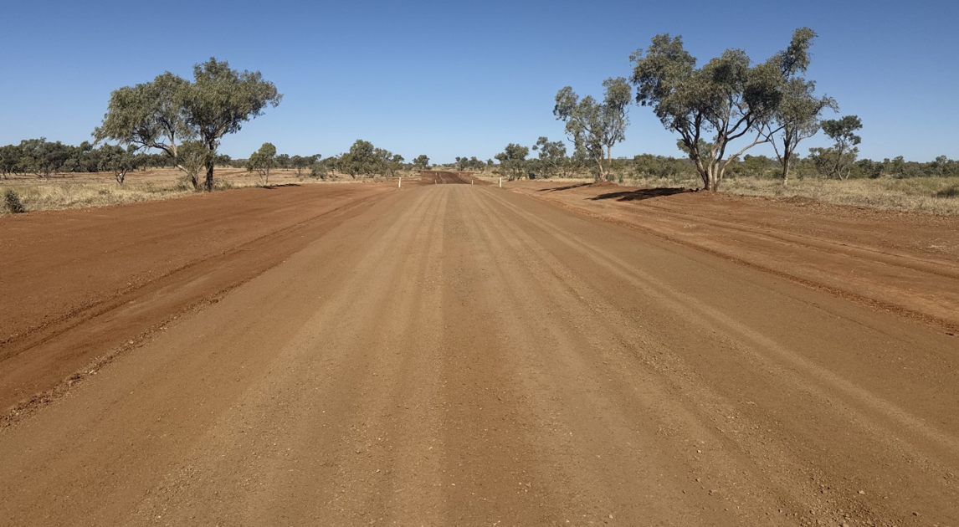
Response 2

Photograph 3 | 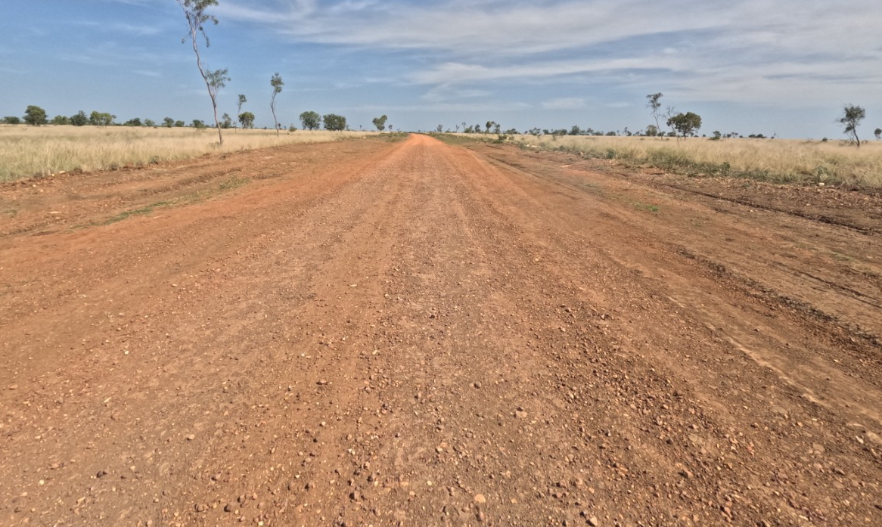
Response 3

Without imported material
Photograph 4 | 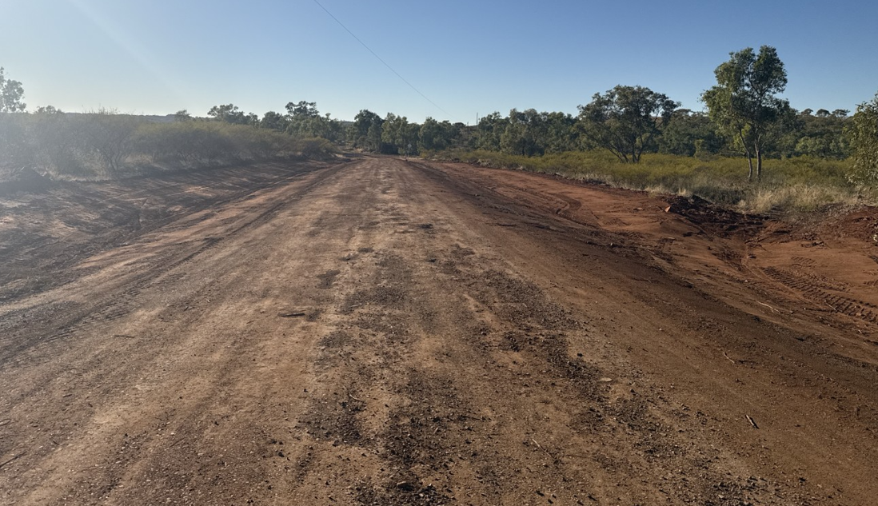
Response 4
Photograph 5 | 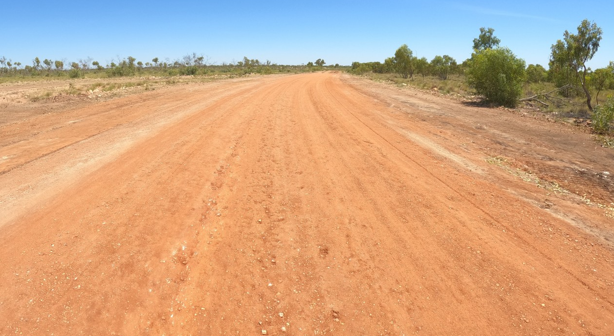
Response 5

Photograph 6 | 
Response 6

Schedule I – Program

Schedule I1 – Program
Provide as a separate attachment a program for WUC which:
  - demonstrates that the Respondent could, if the Respondent’s Response is successful, satisfactorily complete the Works by the date or within the period described in the Tender Form for completion;
  - complies with the requirements of a program stated in the General Specification or elsewhere in the Request for Tender;
  - takes account of any constraints to the program stated in the General Specification or elsewhere in the Request for Tender;
  - is in Microsoft Project format;
  - shows any relevant separable portions; and
  - shows how WUC will be carried out including but not limited to the Contract milestone dates, the commencement and completion dates of each trade and/or subcontract work activity, procurement activities and supply contract activity, with activities linked in a logical progression through a ‘critical path’ and identify any float based on a continuous cycle of work. Minimum milestones to be represented in the program are as follows:
      - Contract award
      - Submission of preliminaries
      - Mobilisation
      - Gravel pit testing and material resource approvals
      - Gravel stockpiling
      - Construction (per road) Completion dates for each road will be set as Contract milestones.
      - Min 10 working day allowance for undertaking safety repair works
      - Practical completion (Per separable portion)
      - Gravel pit remediation and demobilisation

Date for practical completion will be confirmed post tender and will give consideration to the successful tenderer’s program, but will be no later than 30th September 2026 for Separable Portion 1 and 30th November 2026 for Separable Portion 2.
See separate attachment

Schedule J – Pricing, Cash Flow and Variation Rates

Schedule J1 – Pricing
This Schedule is attached separately and is to be completed and returned in Excel format with the Response.

Schedule J2 – Cash Flow Projection

The Respondent is to provide a cash flow projection schedule which:
  - provides anticipated monthly progress claims for the carrying out and completion of WUC inclusive of accumulative totals; and
is consistent with the Program in Schedule I.

Schedule J3 – Variation Rates
Schedule J3.1 – Labour
Role | Labour Charges Per Hour (Excluding GST)
Role | Normal
Project Manager
Labourer
- Skilled
- Unskilled
Truck Driver
Plant Operator
Supervisor
Foreman
Surveyors
Others (Respondent to list as required)

Schedule J3.2 – Plant
Type | Capacity | Plant Hire Per Hour Including Operator  (excluding GST) | Standby Charge Per Hour  (excluding GST)
Backhoe
Truck
Water Truck
Mobile Crane
Excavator
Rock Breaker Attachment
Grader
Bobcat
Dozer
Roller
Others (Respondent to list as required)

Schedule K – Statement of Departures

Schedule K1 – Statement of Departures
The Respondent must provide details of any proposed amendments, qualifications or departures to the draft contract contained in Part 4 – Contract or the scope contained in Part 5 – Scope of the Request for Tender, including:
  - the amendment, qualification or departure proposed;
the reason for proposing the change; and
the effect on the Respondent's Price if the amendment, qualification or departure is accepted.
The Respondent's Response is subject to the following amendments, qualifications or departures:
Part, Clause  or Item | Amendments, Qualifications or Departure | Reduction or increase in Price ($AUD) if amendment, qualification or departure is accepted.*
 |  | IDENTIFY RATE, SUM OR PRICE | [INSERT 'REDUCTION', 'INCREASE' OR 'NO CHANGE'] | $
 |  | IDENTIFY RATE, SUM OR PRICE | [INSERT 'REDUCTION', 'INCREASE' OR 'NO CHANGE'] | $
 |  | IDENTIFY RATE, SUM OR PRICE | [INSERT 'REDUCTION', 'INCREASE' OR 'NO CHANGE'] | $
 |  | IDENTIFY RATE, SUM OR PRICE | [INSERT 'REDUCTION', 'INCREASE' OR 'NO CHANGE'] | $
 |  | IDENTIFY RATE, SUM OR PRICE | [INSERT 'REDUCTION', 'INCREASE' OR 'NO CHANGE'] | $
*Note: If nothing stated, the Respondent warrants that the amendment, qualification or departure will have no effect on the Price.

Schedule L – Additional Information

Schedule L1 – Additional Information
The Respondent may add any additional information relevant to this Response in this Schedule.

Schedule M – Australian Government Work Health and Safety Accreditation Scheme

Schedule M1 – Details of accreditation status
Item | Yes or No
- Is the Respondent accredited under the Australian Government Work Health and Safety Accreditation Scheme?  If yes, state date of accreditation: | ☐ Yes ☐ No
- Is business currently seeking accreditation?  If yes, provide evidence that accreditation is being sought | ☐ Yes ☐ No
- If the Respondent is a joint venture, has the Respondent obtained consent under the Scheme to pursue this Response?  If yes, provide evidence that consent has been obtained | ☐ Yes ☐ No

