Draft Project Decision Framework Policy

Effective from: <Council to insert>
Contact officer: <Council to insert>
Next review date: <Council to insert>
File reference: <Council to insert>

OBJECTIVES

As a component of Council’s Project Decision Framework (PDF), this policy document specifies Council’s overarching intentions and guiding project decision making principles. This policy has been derived from, and is consistent with, the organisational corporate plan and enables the project decision process, strategic actions and outcomes to be developed and implemented. The policy includes a commitment to legislative compliance as well as continual improvement in project decision making across the organisation.

POLICY STATEMENT

Council provides a range of services to the community and, in doing so, is required to ensure these services are sustainable. Typically in any one year, the concepts and ideas that are to be considered at the front end of the formal budget process will be much larger in number than the projects that can actually be supported. Important decisions therefore have to be made as to which of the various concepts and ideas should be progressed for further consideration and those that should not be progressed. Council therefore recognises the benefit in adopting a disciplined approach for consideration of the concepts or ideas, complexity and risks such that approved projects have been subjected to a reasonable level of value for money and assurance type of analysis.

In recognition of the need to establish a system by which project decision making is disciplined, robust and in the best interests of the community, Council aspires to the following:

“To have in place a robust project decision making process to deliver value for money for Council and the community we serve.”
Council’s project decision making mission is guided by the following principles:
- Project Governance and Accountability | - A disciplined approach towards project selection and in undertaking the ‘right’ projects across the organisation.  - Project proposals are prioritised based on a common and agreed set of criteria.  - Project selection is linked to strategic intent.  - Accountability for project decision making activities is unambiguous, accepted and met.  - Industry standards and guidelines are used where appropriate.  - A consistent project decision making language is used.
- Project Information Management | - Council recognises, identifies, records and maintains project information to a level of detail, accuracy and integration necessary for each project to be managed in accordance with the integrated framework.  - Statutory requirements relating to Council’s project work are met (as a minimum).
- Project Lifecycle Management | - Projects are managed from a whole-of-life perspective.  - Risks and opportunities are identified and managed in accordance with the Corporate Risk Framework prior to final project selection.  - Prior to approval of any major project that constitutes a renewal or upgrade to an existing service, a critical review, based on demonstrated service needs is undertaken and the ‘whole-of-life’ cost of that project is determined.
- Service level management | - A planned approach is taken to growth and demographic change through demand management and infrastructure investment using an agreed growth and demographic model.  - Current and desired levels of service are defined that consider technical and community requirements and the cost of services.

SCOPE

Project decision making at <insert name> Council, combines management, governance, financial, economic and technical activities applied to phases of the project lifecycle with the purpose of establishing a common approach for considering opportunities, proposed projects and their subsequent management through to completion.

To improve project selection and delivery, Council adopts a structured decision gate process across the project lifecycle with the initial focus being given to front end phases. Therefore the project lifecycle phases covered by this policy are categorised as follows:
- Identifying and assessing
- Selecting
- Defining
- Executing
- Operating and maintaining
- Decommissioning

Note: This policy applies to construction, process and policy type projects.

DEFINITIONS

As per the Project Decision Framework User Guide.

RELATED POLICIES / LEGISLATION

This policy is aligned with Council’s corporate plans and strategies. It is also central to a suite of related functional level policies that support and guide the management of projects and maximise the business benefits that the opportunities associated with these projects present to Council. Such related functional policies will be subjected to continual review to ensure alignment with all of the higher level elements of the Project Decision Framework User Guide. This policy forms the first part of an integrated approach to decision making in Council, as shown in the following diagram.

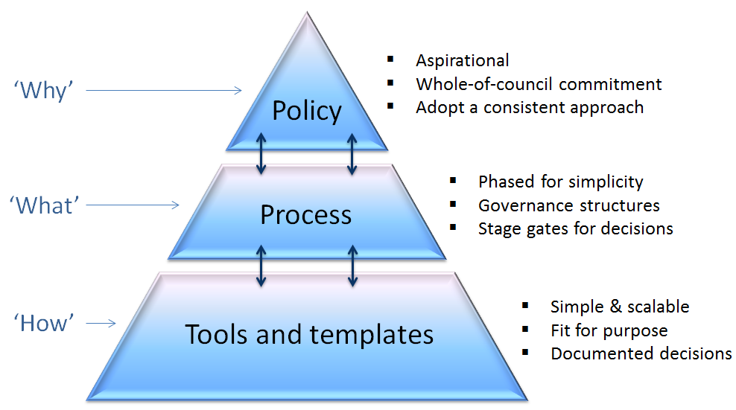

REPORTING REQUIREMENTS

- Current
- Local Government Regulations 2012
  - Community plan
  - Asset management plans
  - Long term financial plans

RELATED DOCUMENTS

- Project Decision Framework User Guide (provided by Queensland Treasury Corporation) including tools and templates

RESPONSIBILITIES

Project decision making responsibilities and relationships have been established as follows:
Council
- To act as stewards for all projects
- To approve Council projects and monitor outcomes
- To set corporate project decision policy and vision
- To set levels of service, risk and cost standards
- To ensure project investment decisions consider whole-of-life costs.
Chief Executive Officer / Executive Leadership Team
- To agree on the Project Decision Framework Policy with Council
- To implement the decision making process with agreed resources and review performance
- To ensure that accurate and reliable information is presented to Council for decision making
- To integrate the Project Decision Framework Policy, process and guidelines into Council’s corporate governance framework.

Project Custodians / Proponents
- To develop proposals for new projects in accordance with Council’s Project Decision Framework
- To ensure proposals include a number of project delivery options in order to determine the most viable option
- To develop and implement project management plans for individual approved projects in accordance with the guidelines
- To deliver levels of service to the agreed risk and cost standards
- To present information to Council and Chief Executive Officer in terms of lifecycle risks and costs.

Project Decision Making Governance Group
- To develop, implement and monitor Council’s Project Decision Framework in accordance with this policy
- Ensure promotion and implementation of effective decision gates throughout each phase of the project lifecycle
- Evaluate and monitor key performance outputs/criteria following implementation.

Sponsor
Business Owner
Policy Implementation

Disclaimer
Queensland Treasury Corporation (QTC) has prepared this template for use solely by Queensland local governments (the User) to assist in the consideration of project proposals as they progress through each of the Project Decision Framework stages. The template should not be used for any other purpose.

As use of this template is intended for Queensland local government only, it should not to be provided or disclosed to, nor relied upon by, any other party without QTC’s express written consent.

The accuracy of the template and its outputs is significantly determined by the accuracy, currency, completeness and applicability of the information entered by the User. It is also determined by the User's understanding of the template’s underlying methodology and its appropriateness to the User's business. QTC is not in a position to review and verify the suitability of the template or its inputs to specific situations being examined by the User and, therefore, QTC accepts no responsibility for the incorrect application of the template by the User or the entry of incorrect information into the template.

The outputs of the template should be used as a guide only. Specific advice should be obtained before acting on the basis of any output of the template.

Neither QTC nor any of its employees or agents accepts any liability for any loss or damage suffered by any person as a result of that person or any other person placing any reliance on, or acting on the basis of, the contents of the template or any outputs generated by the template. To the extent permitted by law, QTC expressly excludes any representation or warranty in relation to the accuracy, currency and completeness of the template. To the extent permitted by law, by using the template you agree that any QTC liability in connection with the template will be limited to the amount of fees received by QTC in relation to the template.

QTC does not provide legal, tax or accounting advice. Such advice should be sought from an independent expert practitioner before applying the information contained in the template.

© Queensland Treasury Corporation

