

Etheridge Shire Council
THE PURCHASE OF VACANT
ALLOTMENT SITUATED AT
7 Sixth Street, FORSAYTH QLD
FOR SALE BY PUBLIC TENDER
No: ESC2022-003

The Etheridge Shire Council invites Expressions of Interest from interested parties for the purchase of vacant allotment situated on Sixth Street, Forsayth. Described as L3 MPH2253, (Land Area, 1854m2).
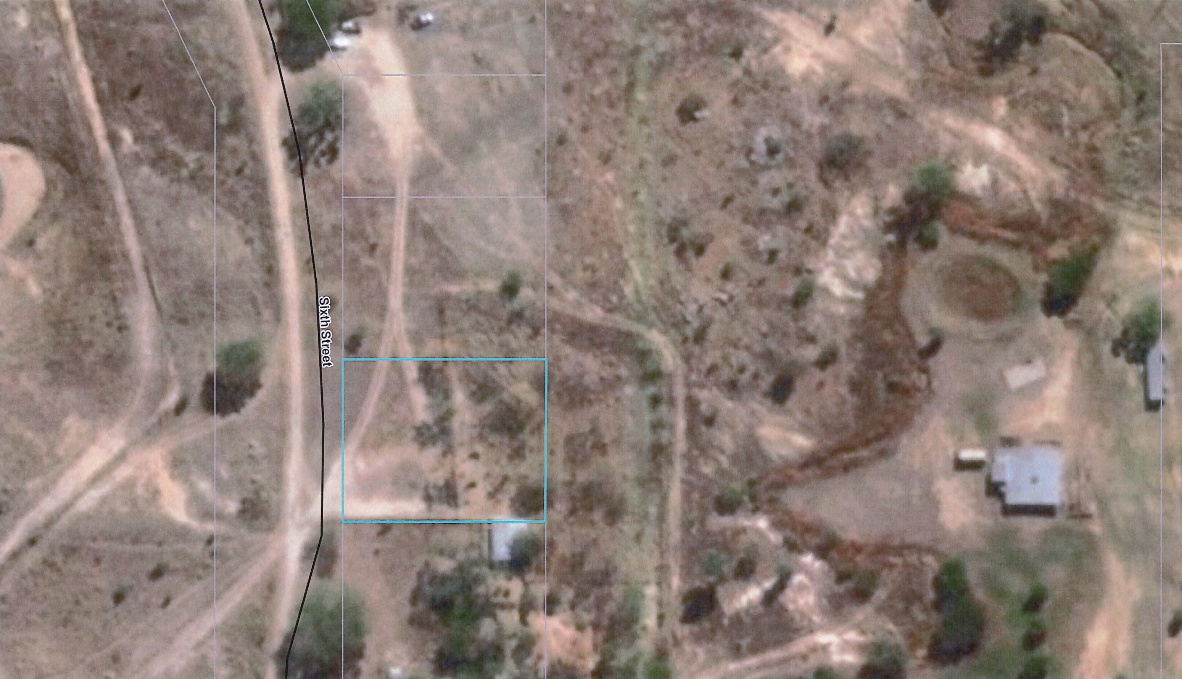

Please Note:

Tender Documentation may be obtained from Etheridge Shire Council’s website, www.etheridge.qld.gov.au under Tenders (ESC-2022-03)

Expressions of Interest close at 3.00pm (AEST) Friday 20th May 2022.

NOTE: Tenderers are to note the delivery address of their EOI and allow sufficient time for their EOI’s to be delivered to Georgetown by the closing date and time.

Ken Timms Po Box 12
CHIEF EXECUTIVE OFFICER GEORGETOWN QLD 4871

